ADMIN MODULE

1. Home Page or Landing Page

This is the main landing page where the user can see the information like the services they’re offering and the current reviews.

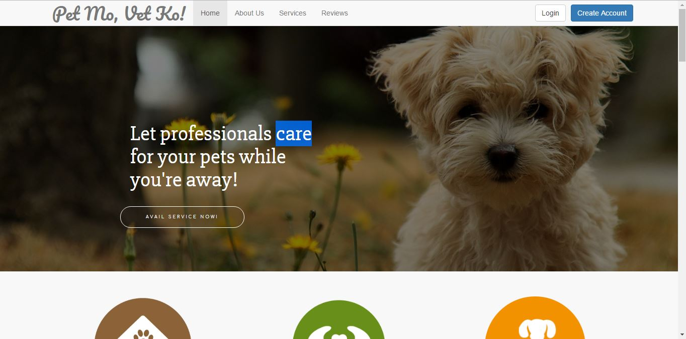

1. About Us

This page tells us about the company.

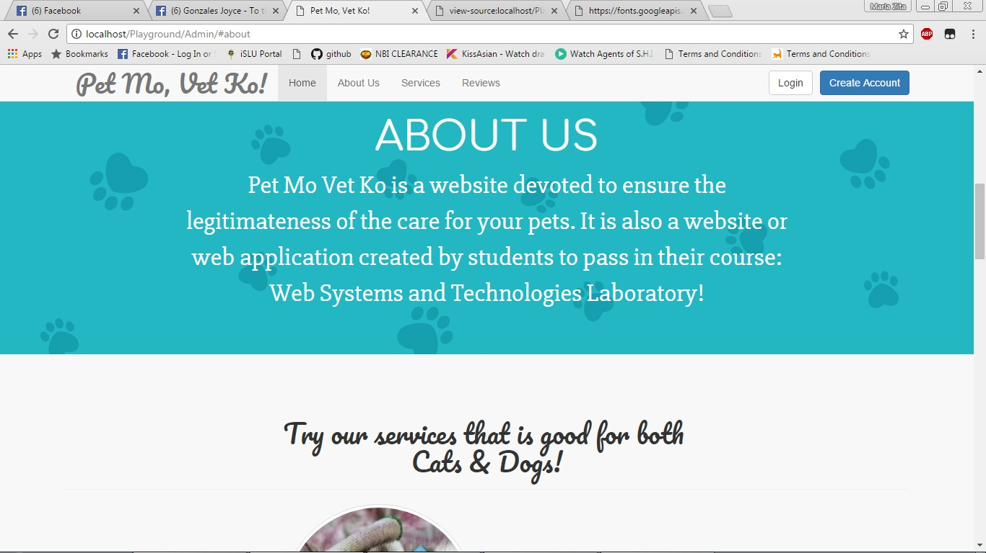

1. Services

These are the list of the current services they’re offering.

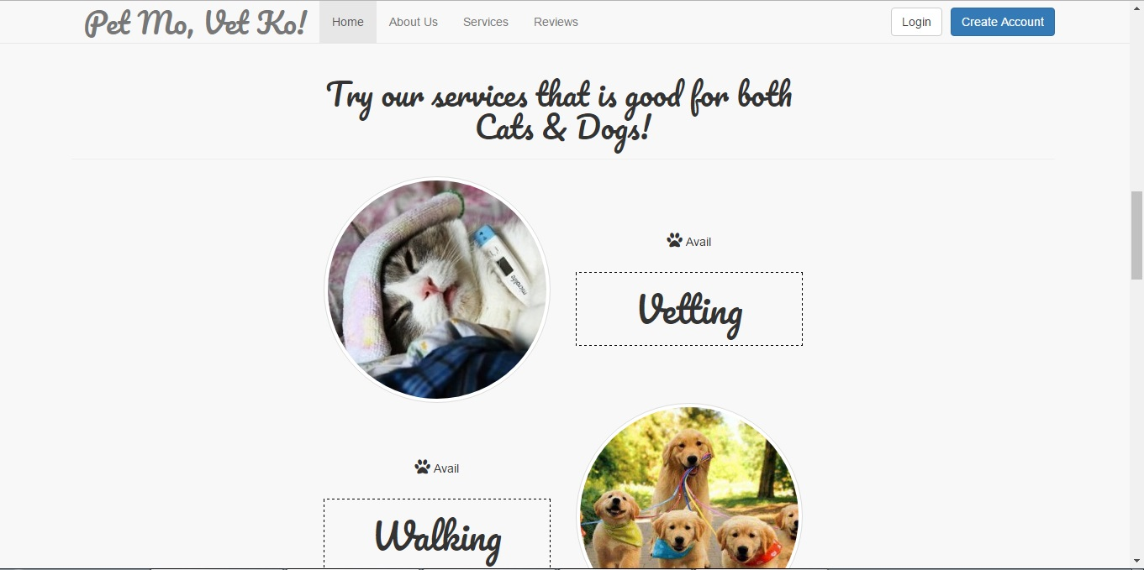

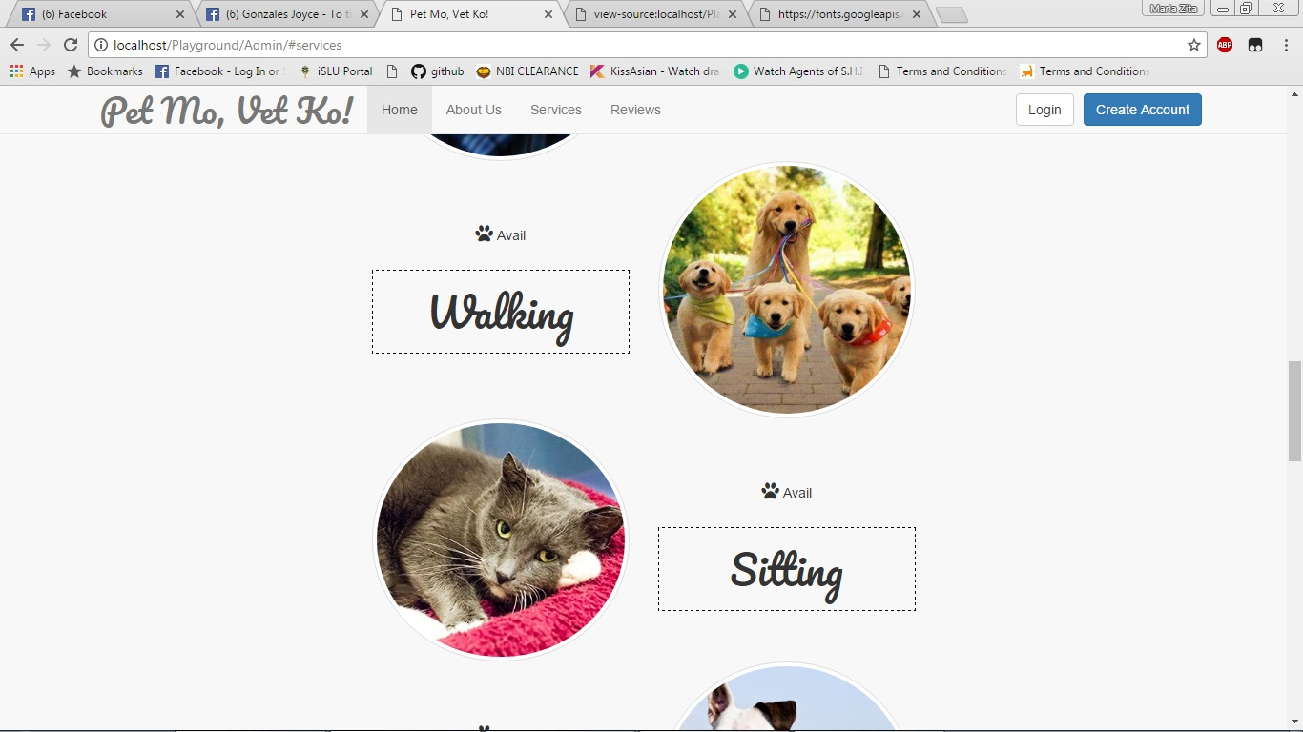

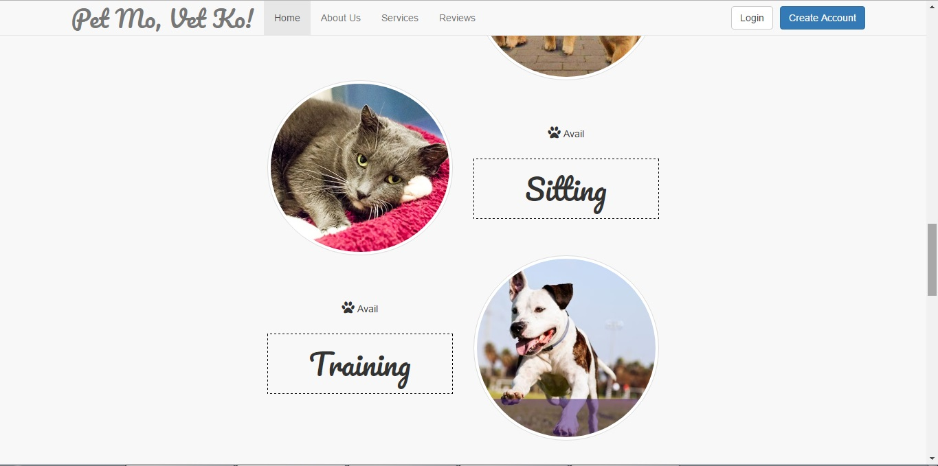

1. Reviews

This is the page where you can see the comments and/or suggestions of the previous customers and service providers.

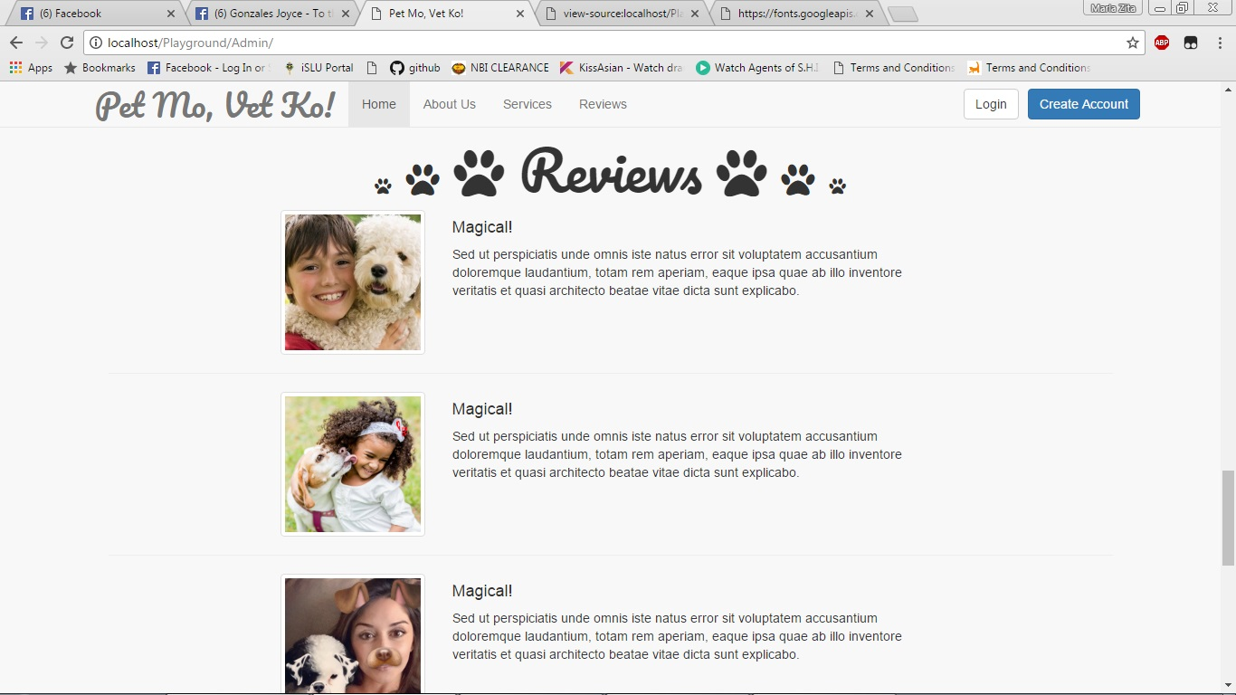

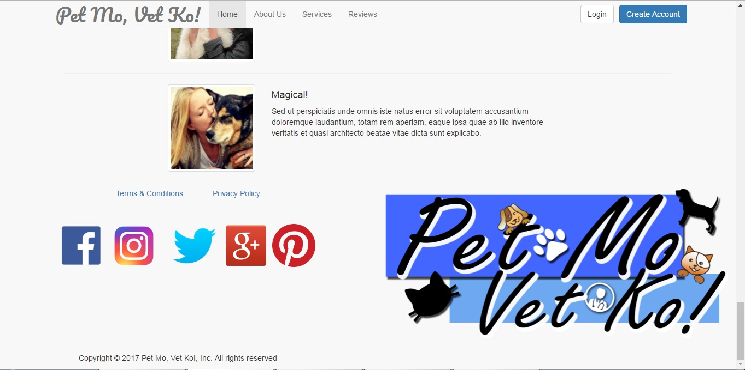

1. Register Page for Customer

Before you can start a transaction, you must register first as a customer or as a service provider. This is the registration page for the customer.

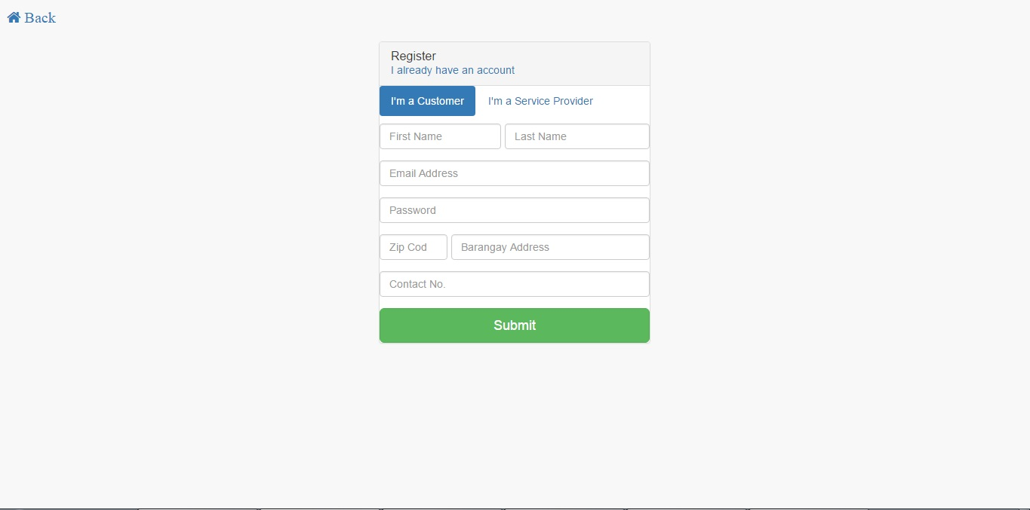

1. Register Page for Service Provider

This is the registration page for the service provider.

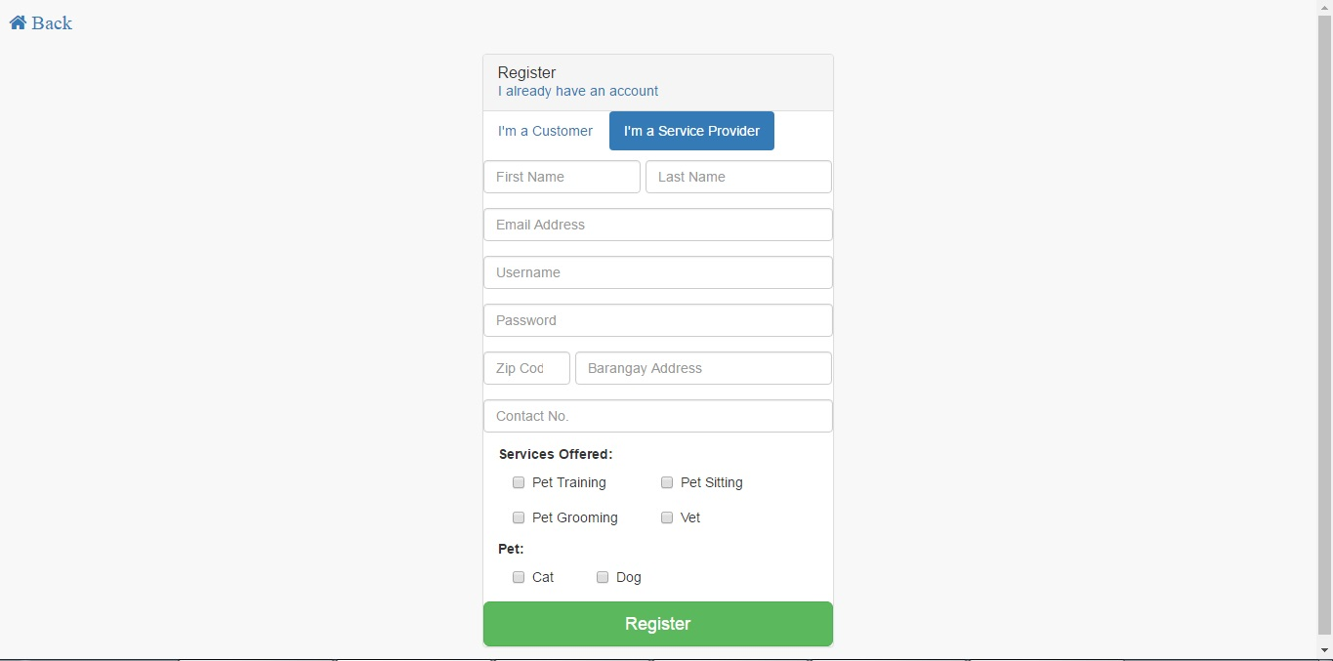

1. Log in Page for Customer.

Once registered as a customer, this is where you can enter you user credentials as a customer. As for the service provider, the admin will have to accept your registration first before you can log in as a service provider.

